
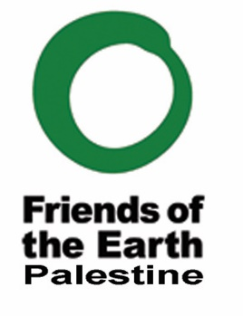


Call for Applications: Palestine Youth Climate Justice Training
Name:*
Your answer
Age:*
Your answer
Email:*
Your answer
Phone Number :*
Your answer
Choose
City:*
Your answer
Education:*
Your answer
What is your knowledge and experience on climate change/action? (no more than 500 words)*
Your answer

What is your motivation to work on climate action and participate in this training program? *
Your answer
Share your ideas about the ways that broader global community can oppose climate injustice and work toward climate justice in Palestine.
Your answer

Upload your CV: *
References:
Add two references who are familiar with your work.
NAME POSITION EMAIL PHONE

